**Python Assignment**

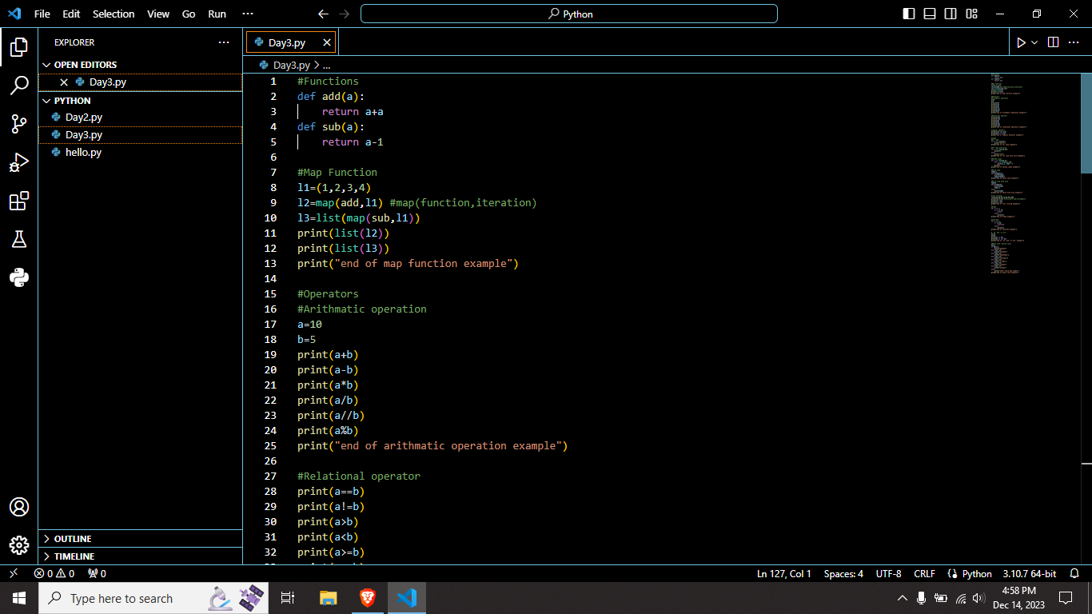

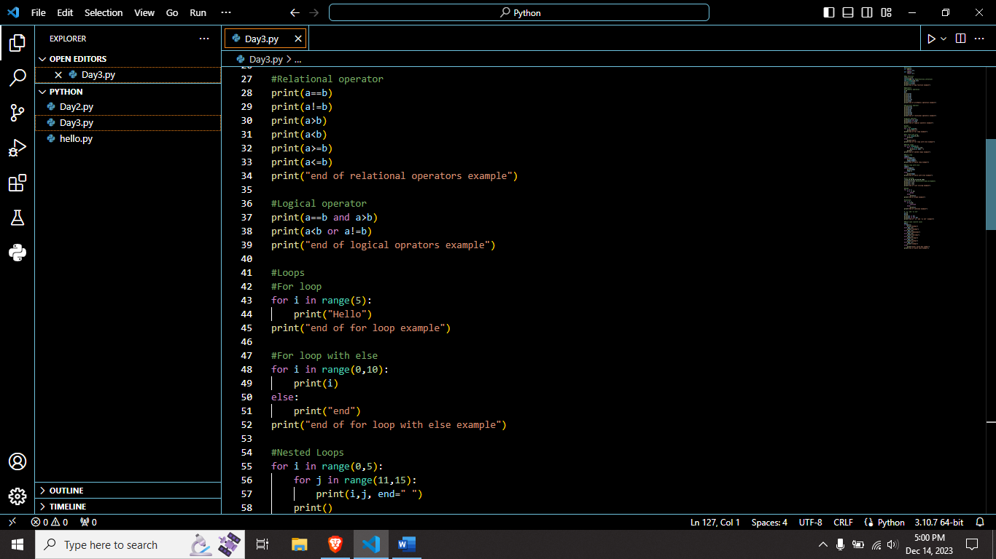

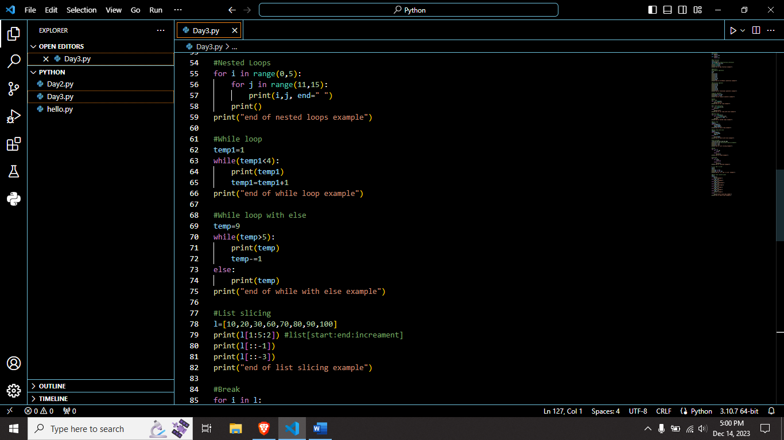

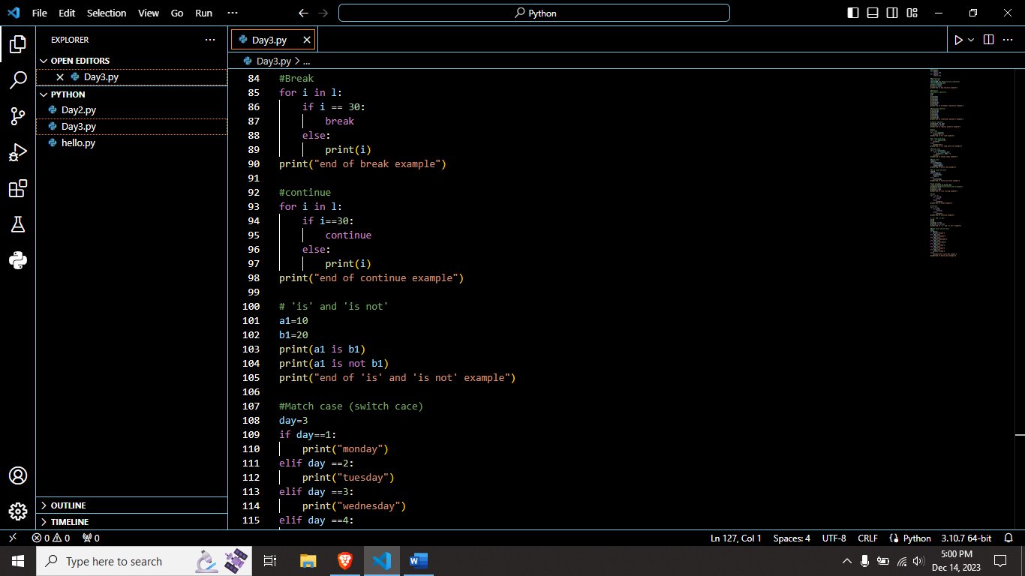

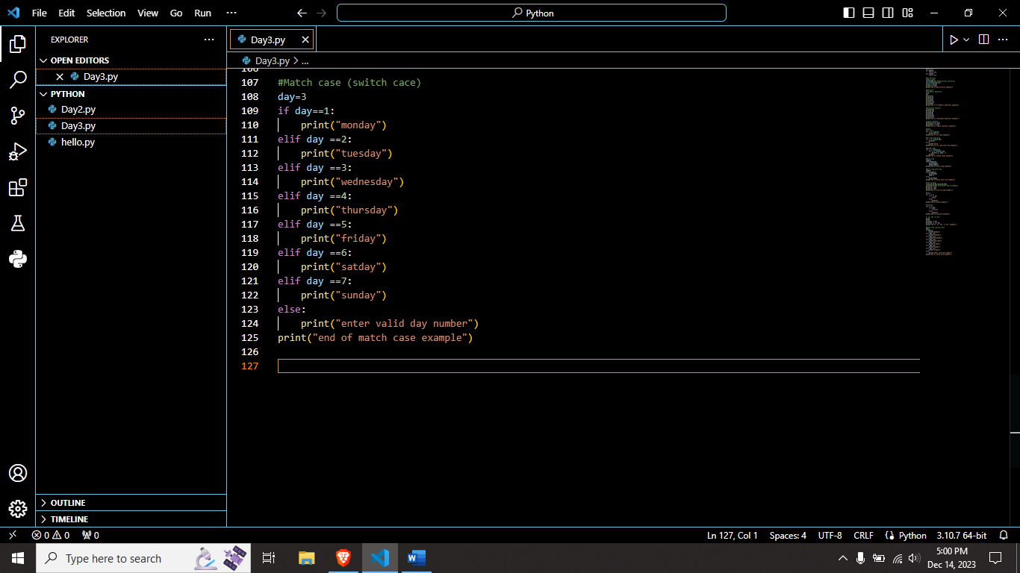

I write a python code for

* Function
* Map function
* Operators
  + - 1. Arithmetic operator
      2. Relational operator
      3. Logical operator
* Loops
  + - * 1. For
        2. For else
        3. While
        4. While else
        5. Nested Loop
* List slicing
* Break, continue
* Match case

**Output:**